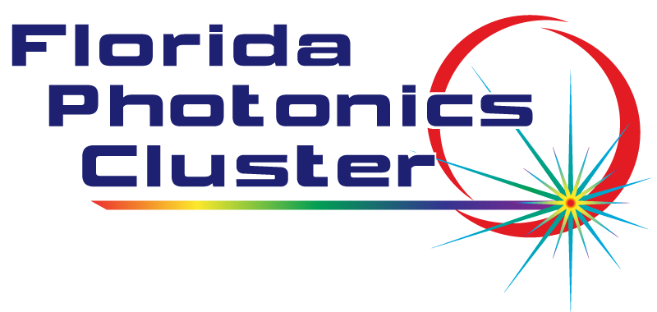

Florida Photonics Cluster – Technology Showcase, virtual via Zoom

Wednesday, 24 March 2021, 3:00-4:30 PM EST
Chair: Alexei Glebov, FPC President
Agenda:

3:00 pm – Welcome, Introductions, FPC Business Updates, Alexei Glebov, FPC President
3:15 pm – Presentation: "Expanding Raman to New Markets”, Scott Scargle, Director of Strategic Markets, Ocean Insight
3:30 pm – Presentation: “Thermally Drawn Ultra-Thin Optical filters: A New Tool in the Optics Toolbox with Many Unique Features”, Hooman Banaei, PhD – CEO/Founder, Everix
3:45 pm – Presentation: “High Accuracy Photonics Packaging Equipment - From Prototype to Production”, Neil O’Brien, General Manager, FineTech USA
4:00 pm – Presentation: “Optronic Laboratories’ LED-Based Sphere Calibration Standard”, Christopher Gordon, Product Scientist, Optronic Labs
4:15 pm – Presentation: “Optical Coating Insight and Manufacturing Methods”, Chris Toomey, Regional Sales Manager, OptoSigma

